Reprinted from ABC website.
By Nelli Saarinen
Posted 14 Dec 2023.
3G Phone Network Closure

Australia's 3G network shut down will begin this Friday, when Vodafone becomes the first of the big telcos to switch its service off.
All three of Australia's largest telcos are set to close down their 3G networks over the next nine months.
Some devices, including older mobile phones, baby monitors and medical devices still rely on the 20-year-old network that is now being phased out in favour of faster 4G and 5G networks.
Here's what you need to know ahead of Friday's closure.

When is each telco shutting down 3G?
- Vodafone will shut down its 3G services on Friday, December 15 2023
- Telstra will shut down its 3G network on June 30, 2024
- Optus will switch off its 3G network in September 2024

What does the network closure mean?
If your device is only able to connect to 3G, you won't be able to connect to your service provider's network after it has been shut down.
That means it will no longer be possible to make phone calls, send texts or access mobile internet on the device. Wi-fi access will still be possible.
To continue using mobile service, people with these older devices will have to upgrade to a model that can connect to 4G or 5G.
The telcos have warned that people with 3G mobile devices will not be able to call Triple-0 after networks cease to operate.
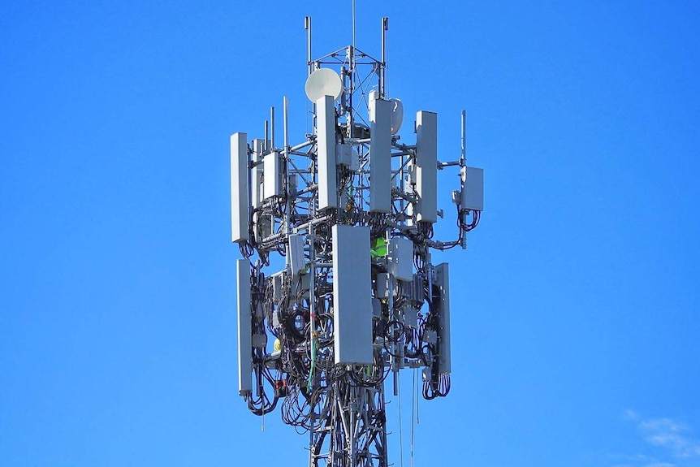
All three of Australia's largest telcos are shutting down their 3G networks in the next nine months.(ABC News: Chris Gillette)

What devices are affected?
The change will affect many different types of devices, from EFTPOS machines and farming equipment to baby monitors and medical devices.
The most common devices impacted will be 3G-only mobile phones.
Some older 4G phones that do not have "VoLTE" (Voice over Long Term Evolution) capacity will not be able to make and receive voice calls, Vodafone said.
Here are some of the most popular devices to be affected:
- Alcatel 2038
- Alcatel OneTouch 2045
- Apple iPhone 5
- Apple iPhone 5C
- Apple iPhone 5S
- Aspera A42
- Doro PhoneEasy 623 OPTUS
- Doro 6521
- Google Pixel 2 XL
- Huawei E5331
- Huawei E5251s-2
- Huawei Y6 Prime
- Nokia 301
- Oppo A57
- Oppo F1s
- Oppo F5 Youth
- Optus X Smart
- Samsung Galaxy J1 Mini
- Samsung Galaxy S5
- ZTE Blade A0605

How do I find out if I'm affected?
An easy way to check is to see if it says "4G" or "5G" on your phone screen. However, devices that are compatible with the more modern networks will still connect to 3G in areas where 4G coverage isn't strong.
It is best to check your user manual or contact the manufacturer to find out if your device relies on 3G network only.
You can also contact your mobile service provider for assistance.

